Name:

Laiba Faisal

Roll Number:

213002

Class:

BSCS-B

Subject:

Mobile Computing Lab

Lab Task #:

3

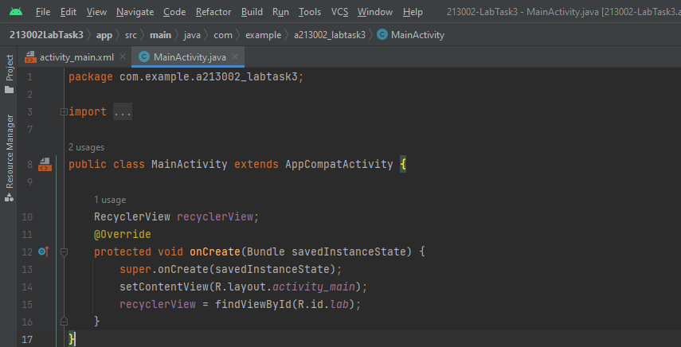

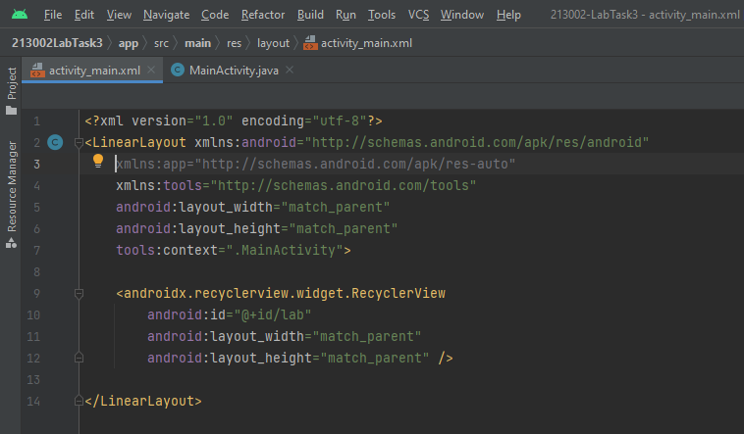

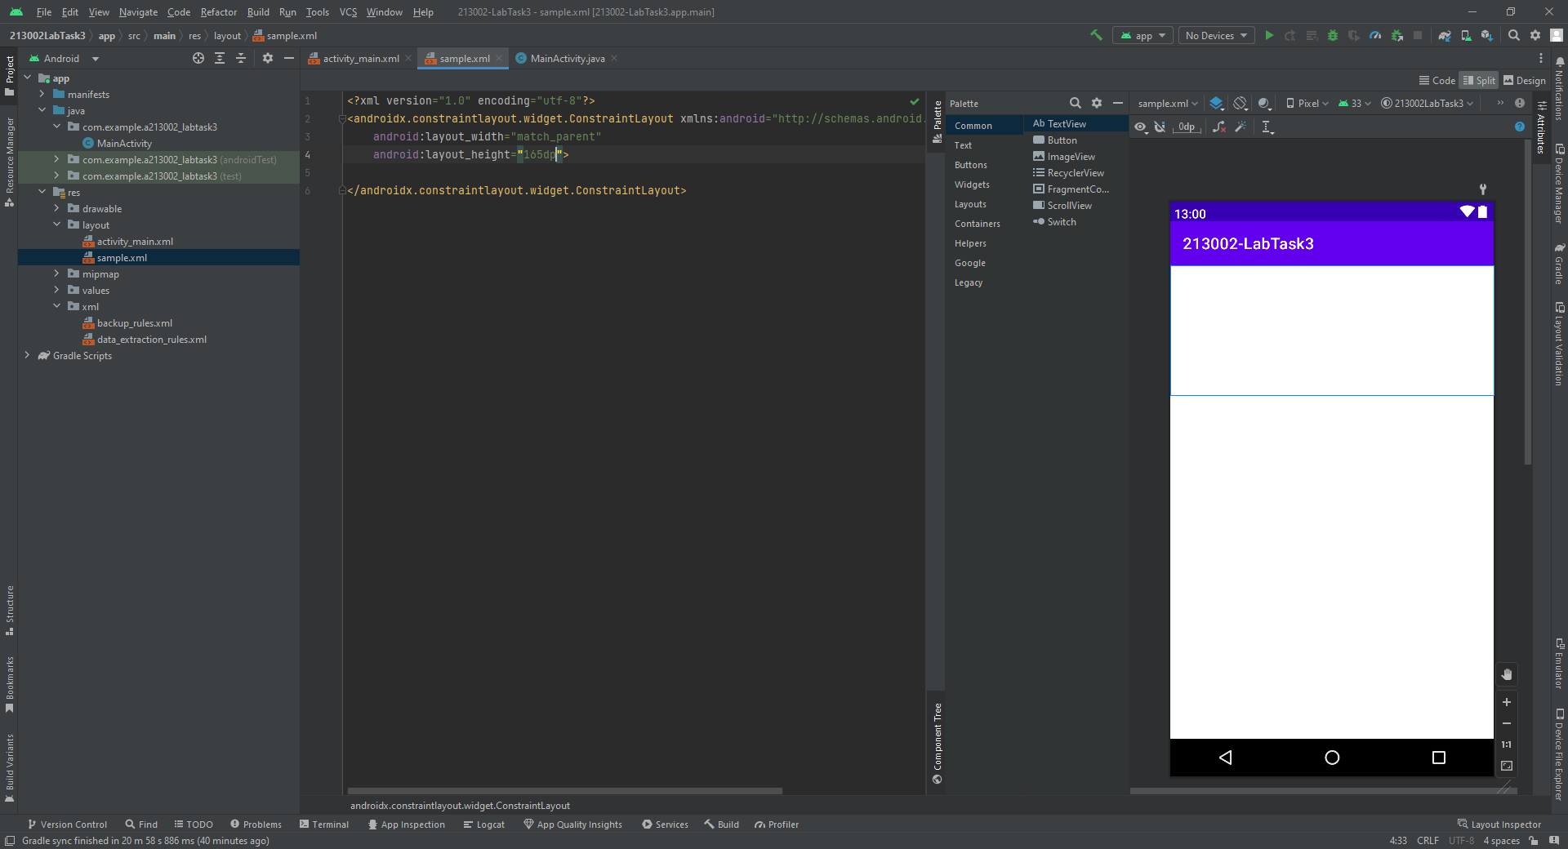

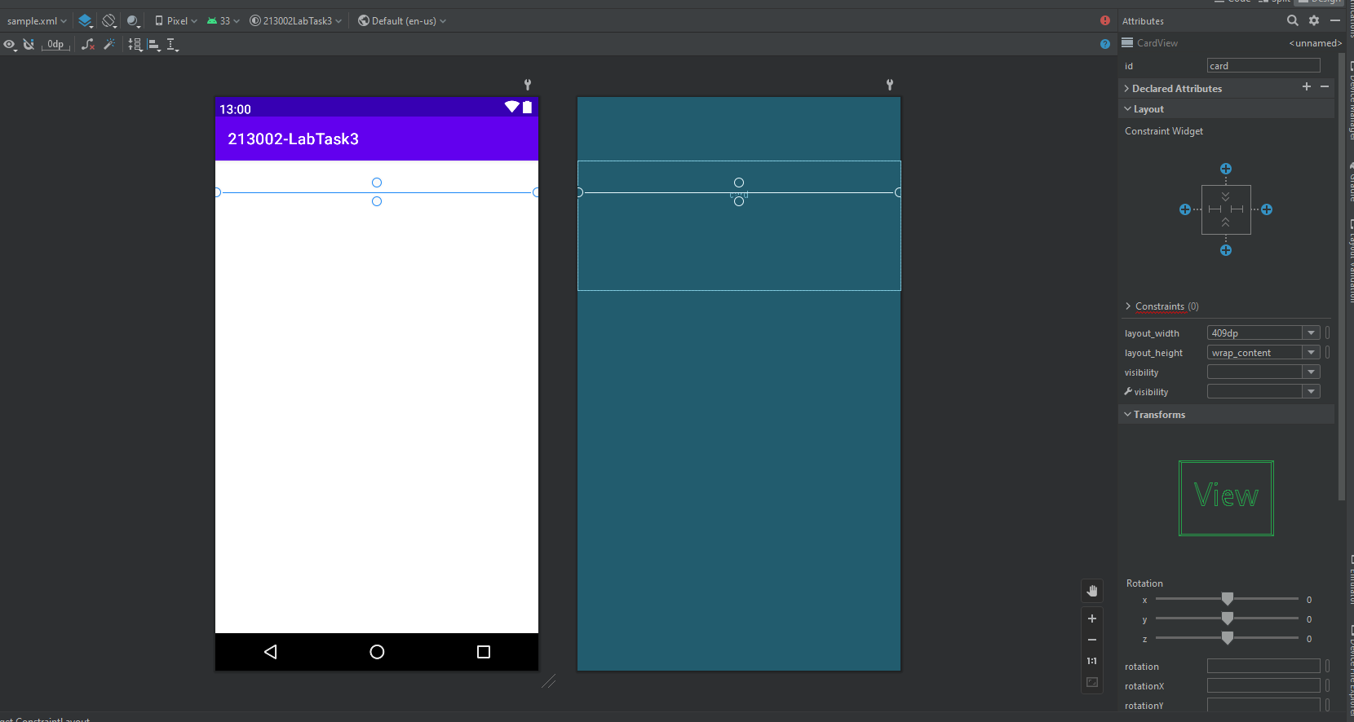

C:\Users\213002\AndroidStudioProjects\213002LabTask3\app\src\main\res